Concept Cube Assignment
Purpose
- The purpose of this project is to help you review a specific religion
- The work should be quality, be colorful and interesting, and should use a carefully chosen set of images, graphs, songs, selections from stories, pictures, etc., to present your religion

Instructions
- There is a list of possible topics you can choose from below. One side of the cube will be a "title" side and this will contain the topic.

- The next thing you need to do is to think back to five important "features" of your topic event*. Think- deities (gods), practices, stories, symbols, important people, etc.

- Rank the five significant "causes" in order from least to most important.

- Get a regular sized piece of construction paper. You do not have to use white. You can either trace the pattern available in class, or you can measure out your own as indicated below.
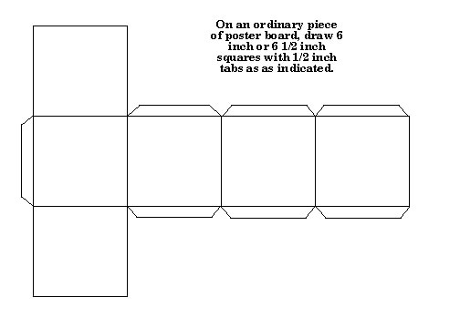

- It is a good idea to sketch out how you plan to proceed before you go hunting your materials.

- Start with your title side and think of an artful way of depicting it. Then move down your list to the most significant feature, the next most significant feature, etc., until you have planned out how you are going to represent each of these "faces" of the cube.

- Whatever you do, you cannot just write words on the sides of the cube; you must use graphs, pictures, song lyrics, stories, etc. And remember color, creativity, neatness all count.

Possible topics:

- Jainism
- Sikhism
- Buddhism
- Islam (cannot just do the 5 pillars!)
- Hinduism

